Roll No : 45

Name:- Jayant Sanjay Patil

Practical No : 1

Practical Name : Set up a GitHub account and send an email message to friend telling to your friend about the account.

If you don't already have a GitHub account, here's how to create one.
- Open https://github.com in a web browser, and then select Sign up.
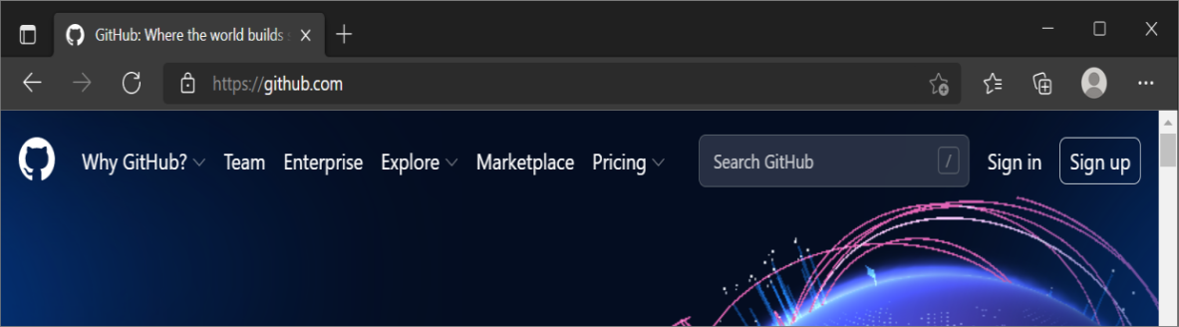
- Enter your email address.
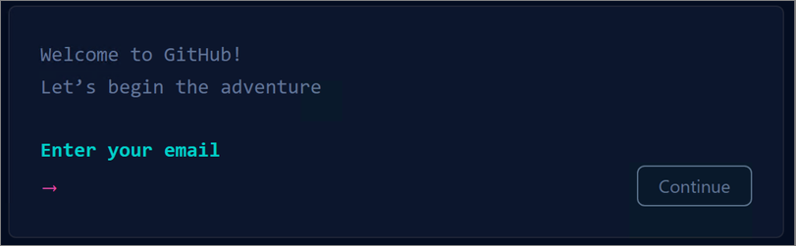
- Create a password for your new GitHub account, and Enter a username, too. Next, choose whether you want to receive updates and announcements via email, and then select Continue.
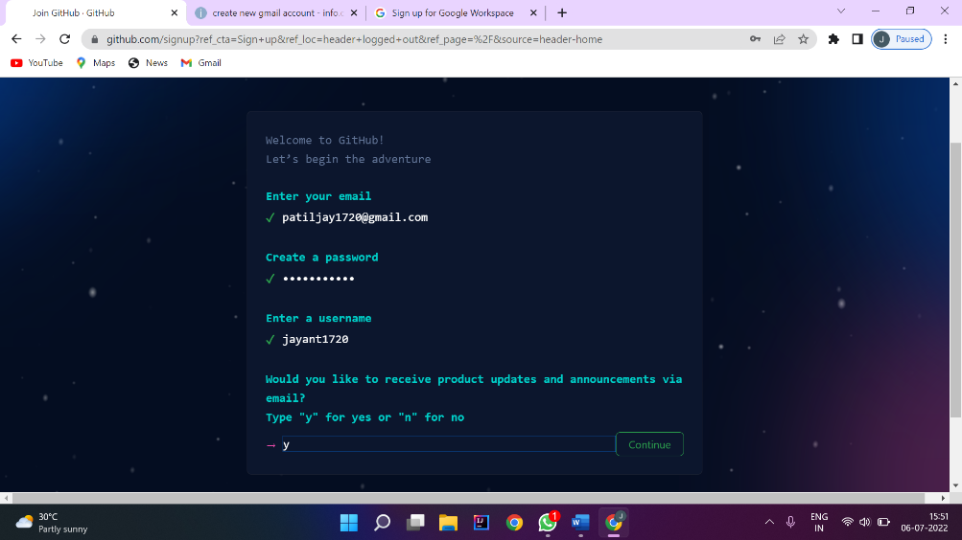
- Verify your account by solving a puzzle. Select the Start Puzzle button to do so, and then follow the prompts.
- After you verify your account, select the Create account button.
- Next, GitHub sends a launch code to your email address. Type that launch code in the Enter code dialog, and then press Enter.
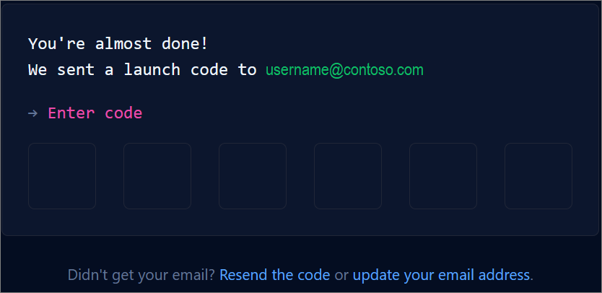
- GitHub asks you some questions to help tailor your experience. Choose the answers that apply to you in the following dialogs:
  - How many team members will be working with you?
  - What specific features are you interested in using?
- On the Where teams collaborate and ship screen, you can choose whether you want to use the Free account or the Team account. To choose the Free account, select the Skip personalization button.
GitHub opens a personalized page in your browser.

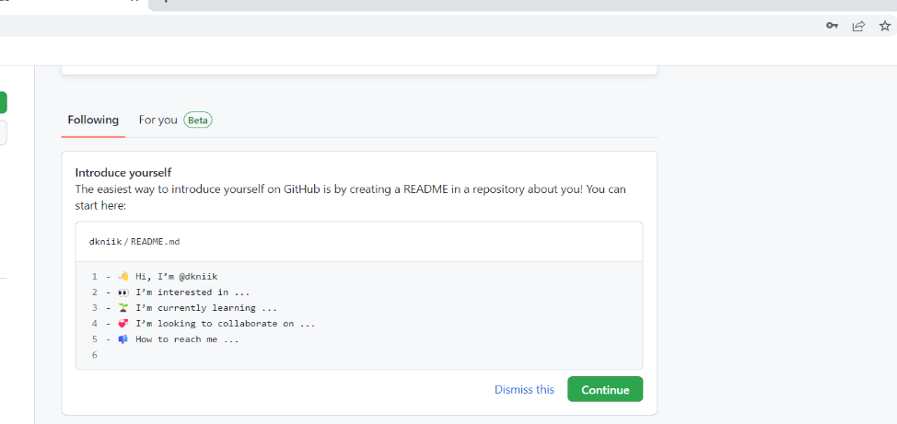
Congratulations! You've successfully created your GitHub account.
Paste the screen shots of email which you had sended to your friend through Github
Step1: Go to Github account and login.
Step2: After login, click on any created remote repository.
Step3: Go to settings of that particular remote repository and click on Email notifications and add the email id of your friend which you had to send the mail.
Step4: Make changes on your remote repository by editing any existing file or you can create any new file also.
Step5: Now, tell your friend to check his/her mail id by login.

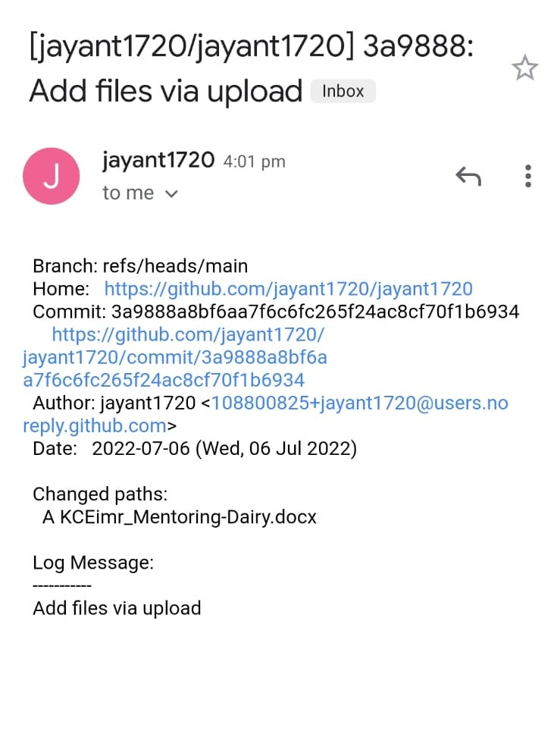

Roll No:-45
Name :- Jaynt Sanjay Patil
Practical No:-3
Practical Name:- use git add to file to the respository .use git commit to your change
__________________________________________________________________________________

Nikhil@Dknik MINGW64 ~ (main)
$ git clone https://github.com/jayant1720/jayant1720.git
Cloning into 'jayant1720'...
remote: Enumerating objects: 6, done.
remote: Counting objects: 100% (6/6), done.
remote: Compressing objects: 100% (5/5), done.
remote: Total 6 (delta 0), reused 0 (delta 0), pack-reused 0
Receiving objects: 100% (6/6), 133.91 KiB | 144.00 KiB/s, done.

Nikhil@Dknik MINGW64 ~ (main)
$ cd jayant1720

Nikhil@Dknik MINGW64 ~/bhushan-narkhede/bhushan-narkhede (main)
$ touch jayant.txt

Nikhil@Dknik MINGW64 ~/bhushan-narkhede/bhushan-narkhede (main)
$ git add jayant.txt

Nikhil@Dknik MINGW64 ~/bhushan-narkhede/bhushan-narkhede (main)
$ git commit -m "first commit"
Author identity unknown

*** Please tell me who you are.

Run

git config --global user.email "you@example.com"
git config --global user.name "Your Name"

to set your account's default identity.
Omit --global to set the identity only in this repository.

Nikhil@Dknik MINGW64 ~/jayant1720/jayant1720 (main)
$ git config --global user.name "jayant1720"

Nikhil@Dknik MINGW64 ~/ jayant1720/jayant1720 (main)
$ git config --global user.email "patiljay1720@gmail.com"

Nikhil@Dknik MINGW64 ~/ jayant1720/jayant1720 (main)
$ git commit -m "first commit"
[main 679692b] first commit
1 file changed, 0 insertions(+), 0 deletions(-)
create mode 100644 jayant.txt

Nikhil@Dknik MINGW64 ~/ jayant1720/jayant1720 (main)

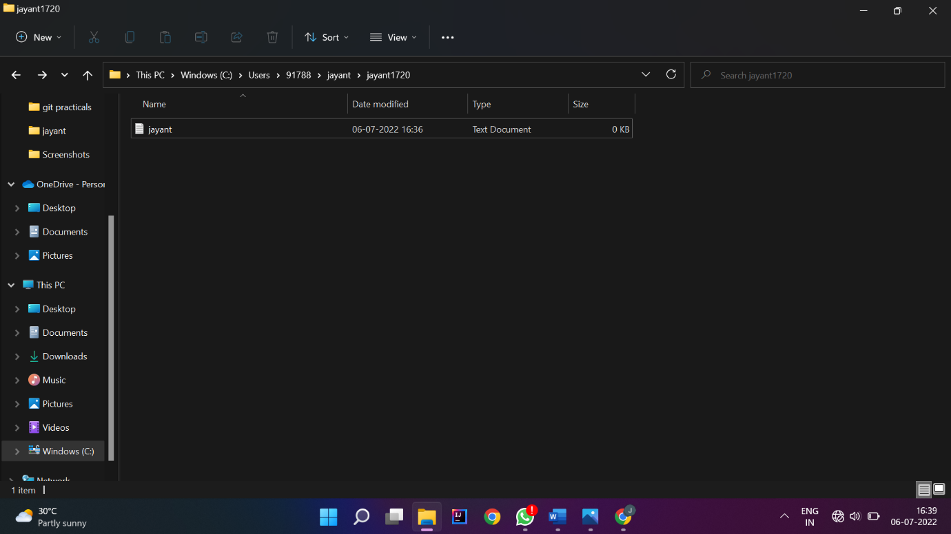

Roll No : 45
Name:- Jayant Sanjay Patil
Practical No : 4
Practical Name : Use git push to send your change to primary repository.
Look Online to see if your change has been pushed.

Nikhil@Dknik MINGW64 ~ (main)
$ git clone https://github.com/jayant1720/jayant1720.git
Cloning into 'jayant1720'...
remote: Enumerating objects: 6, done.
remote: Counting objects: 100% (6/6), done.
remote: Compressing objects: 100% (5/5), done.
remote: Total 6 (delta 0), reused 0 (delta 0), pack-reused 0
Receiving objects: 100% (6/6), 133.91 KiB | 144.00 KiB/s, done.

Nikhil@Dknik MINGW64 ~ (main)
$ cd jayant1720

Nikhil@Dknik MINGW64 ~/jayant1720 (main)
$ git init jayant1720
Initialized empty Git repository in C:/Users/91788/jayant1799/.git/

Nikhil@Dknik MINGW64 ~/jayant1720/jayant1720 (main)
$ touch patil.docx

Nikhil@Dknik MINGW64 ~/jayant1720/jayant1720 (main)
$ git add patil.docx

Nikhil@Dknik MINGW64 ~/jayant1720/jayant1720 (main)
$ git commit -m "push command"
[main 4779ba1] push command
1 file changed, 0 insertions(+), 0 deletions(-)
create mode 100644 patil.docx

Nikhil@Dknik MINGW64 ~/jayant1720/jayant1720 (main)
$ git push -u origin main
Enumerating objects: 4, done.
Counting objects: 100% (4/4), done.
Delta compression using up to 8 threads
Compressing objects: 100% (2/2), done.
Writing objects: 100% (3/3), 276 bytes | 276.00 KiB/s, done.
Total 3 (delta 0), reused 0 (delta 0), pack-reused 0
https://github.com/jayant1720/jayant1720.git
015a001..4779ba1 main -> main
branch 'main' set up to track 'origin/main'.

Nikhil@Dknik MINGW64 ~/jayant1720/jayant1720 (main)
$
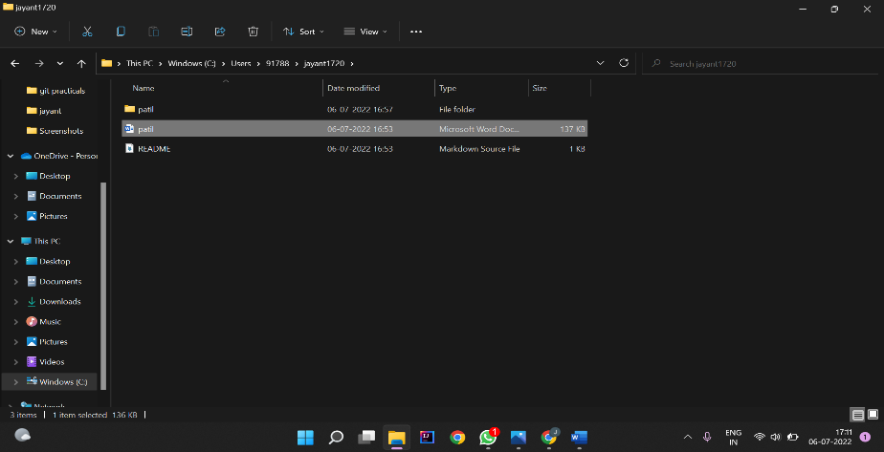

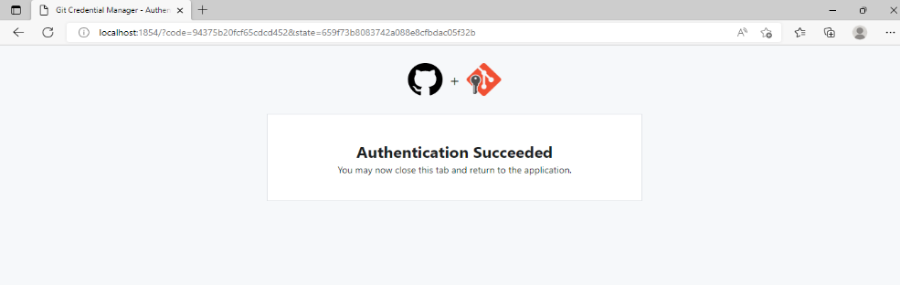

Roll No : 45
Name:-Jayant Sanjay Patil
Practical No : 5
Practical Name : Use Git Pull to get your partners change into your repository.
Verify that you have the new flie.

Nikhil@Dknik MINGW64 ~ (main)
$ git clone https://github.com/jayant1720/jayant1720.git
Cloning into 'jayant1720'...
remote: Enumerating objects: 6, done.
remote: Counting objects: 100% (6/6), done.
remote: Compressing objects: 100% (5/5), done.
remote: Total 6 (delta 0), reused 0 (delta 0), pack-reused 0
Receiving objects: 100% (6/6), 133.91 KiB | 144.00 KiB/s, done.

Nikhil@Dknik MINGW64 ~ (main)
$ cd jayant1720

Nikhil@Dknik MINGW64 ~/jayant1720 (main)
$ git init Jayant1720
Initialized empty Git repository in C:/Users/91788/jayant1720/.git/

Nikhil@Dknik MINGW64 ~/jayant1720 (main)
$ git pull https://github.com/jayant1720/jayant1720.git
remote: Enumerating objects: 4, done.
remote: Counting objects: 100% (4/4), done.
remote: Compressing objects: 100% (3/3), done.
remote: Total 3 (delta 0), reused 0 (delta 0), pack-reused 0
Unpacking objects: 100% (3/3), 10.12 KiB | 398.00 KiB/s, done.
From https://github.com/jayant1720/jayant1720.git
* branch HEAD -> FETCH_HEAD
Updating 1da50b1..f9beb08
Fast-forward
Jayant1720 git patil.docx | Bin 0 -> 12391 bytes
1 file changed, 0 insertions(+), 0 deletions(-)
create mode 100644 jayant1720 git patil.docx

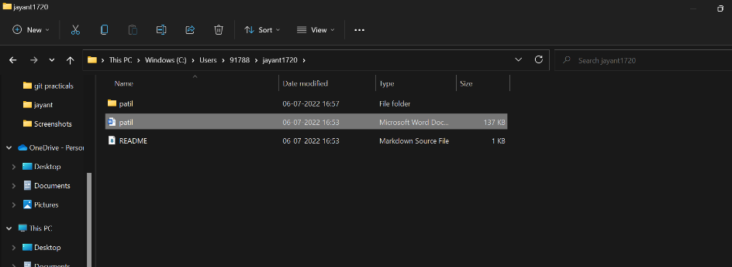

Practical No:6
Roll NO :-45
Name:- Jayant Sanjay Patil
Practical Name:Use git log or git log|less to see a list of changes to the repository
______________________________________________________________________

Nikhil@Dknik MINGW64 ~ (master)
$ git clone https://github.com/jayant1720/jayant1720.git
Cloning into 'jayant1720'...
remote: Enumerating objects: 9, done.
remote: Counting objects: 100% (9/9), done.
remote: Compressing objects: 100% (4/4), done.
remote: Total 6 (delta 0), reused 0 (delta 0), pack-reused 0
Receiving objects: 100% (9/9), done.

Nikhil@Dknik MINGW64 ~ (master)
$ cd jayant1720

Nikhil@Dknik MINGW64 ~/jayant1720 (main)
$ git log
commit dabd6b68cf6da0bc0eab452af45987833e9ec841 (HEAD -> main, origin/main, origin/HEAD)
Author: jayant1720<108719818+jayant1720@users.noreply.github.com>
Date: Tue Jul 5 13:19:54 2022 +0530

Add files via upload

commit b53f95acd3e9f5ec46c435e5874343961eec5b52
Author: jayant1720<108719818+jayant1720@users.noreply.github.com>
Date: Tue Jul 5 12:53:14 2022 +0530

Initial commit

Practical No: 7
Name :- Jayant Sanjay Patil
Practical Name: Use git branch to create a new branch and git checkout to switch branch.
Roll No: 45

comp@com135 MINGW64 ~
$ git clone https://github.com/Shitu18/KBCNMU.git
Cloning into 'KBCNMU'...
remote: Enumerating objects: 3, done.
remote: Counting objects: 100% (3/3), done.
remote: Total 3 (delta 0), reused 0 (delta 0), pack-reused 0
Receiving objects: 100% (3/3), done.

comp@com135 MINGW64 ~ (master)
$ cd KBCNMU

comp@com135 MINGW64 ~/KBCNMU (main)
$ git init
Reinitialized existing Git repository in C:/Users/comp/KBCNMU/.git/

comp@com135 MINGW64 ~/KBCNMU (main)
$ git branch branch2

comp@com135 MINGW64 ~/KBCNMU (main)
$ git checkout branch2
Switched to branch 'branch2'

comp@com135 MINGW64 ~/KBCNMU (branch2)
$ touch srp.txt

comp@com135 MINGW64 ~/KBCNMU (branch2)
$ git add srp.txt

comp@com135 MINGW64 ~/KBCNMU (branch2)
$ git commit -m "This is 7th practical"
[branch2 099e96e] This is 7th practical
1 file changed, 0 insertions(+), 0 deletions(-)
create mode 100644 srp.txt

comp@com135 MINGW64 ~/KBCNMU (branch2)
$ git push -u origin branch2
Enumerating objects: 4, done.
Counting objects: 100% (4/4), done.
Delta compression using up to 4 threads
Compressing objects: 100% (2/2), done.
Writing objects: 100% (3/3), 286 bytes | 143.00 KiB/s, done.
Total 3 (delta 0), reused 0 (delta 0), pack-reused 0
remote:
remote: Create a pull request for 'branch2' on GitHub by visiting:
remote: https://github.com/nikhild/KBCNMU/pull/new/branch2
remote:
To https://github.com/Shitu18/KBCNMU.git
* [new branch] branch2 -> branch2
branch 'branch2' set up to track 'origin/branch2'.

comp@com135 MINGW64 ~/KBCNMU (branch2)
$ git branch --list
* branch2
main

comp@com135 MINGW64 ~/KBCNMU (branch2)
$ git checkout main
Switched to branch 'main'
Your branch is up to date with 'origin/main'.

comp@com135 MINGW64 ~/KBCNMU (main)
$ git branch -d branch2
warning: deleting branch 'branch2' that has been merged to
'refs/remotes/origin/branch2', but not yet merged to HEAD.
Deleted branch branch2 (was 099e96e).

comp@com135 MINGW64 ~/KBCNMU (main)
$ git branch --list
* main

Before pull and merge on remote repository:-

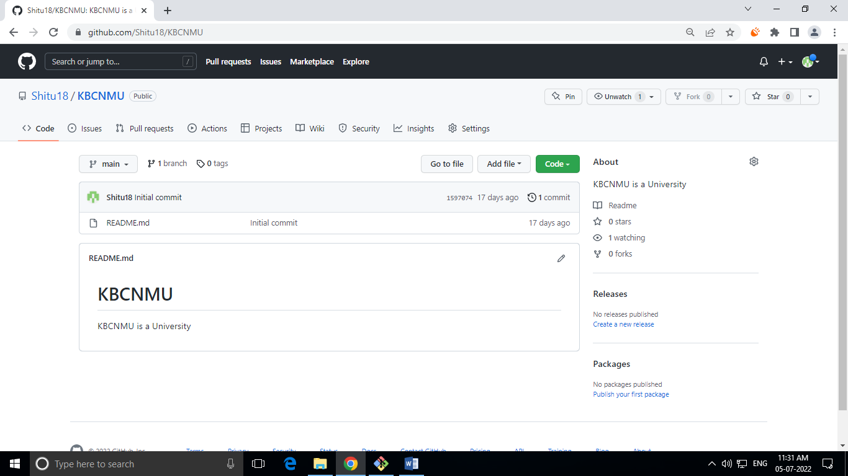
Performing pull request:-

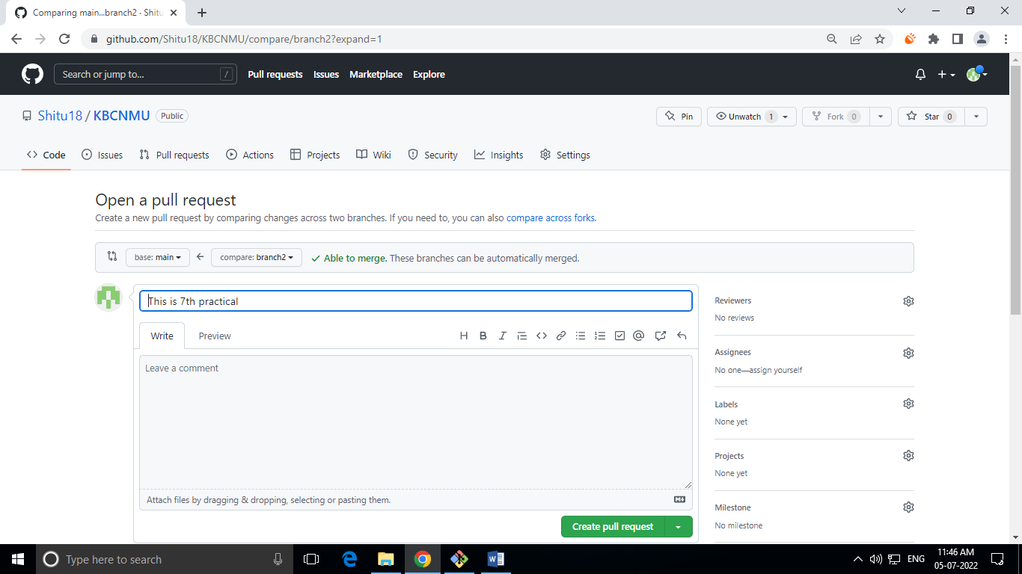

After pull performing merge on repository at a primary branch (main):-

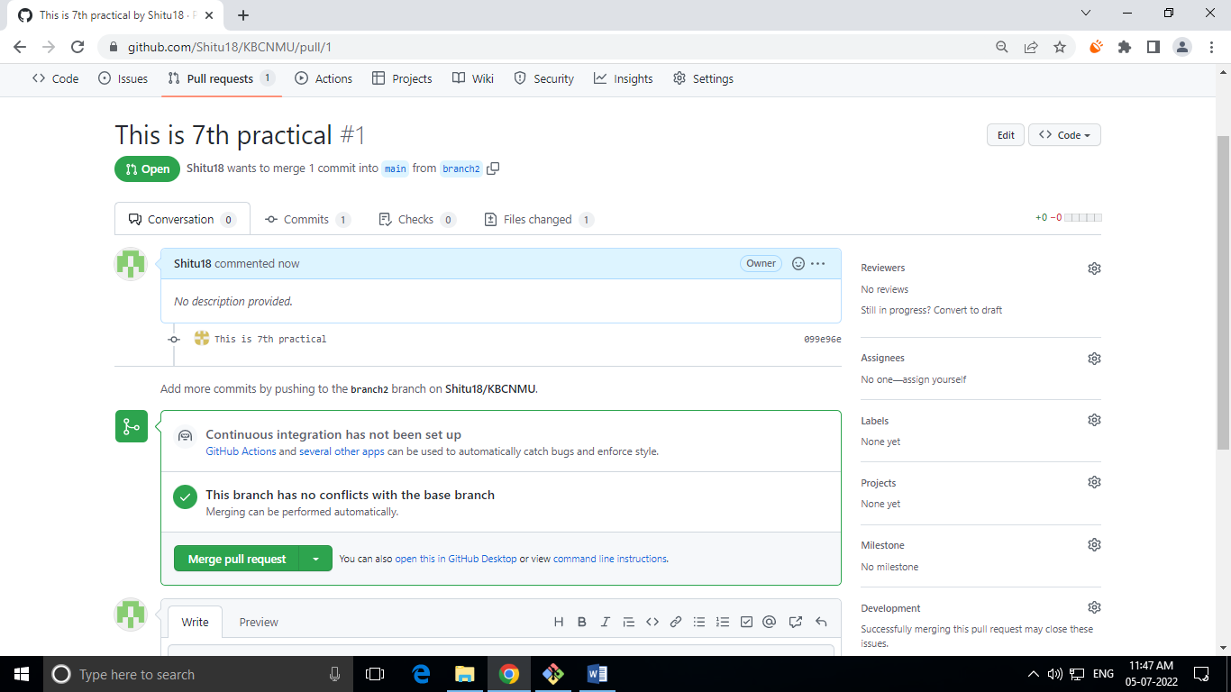

After Merge from branch2 to primary (main) on remote repository:-

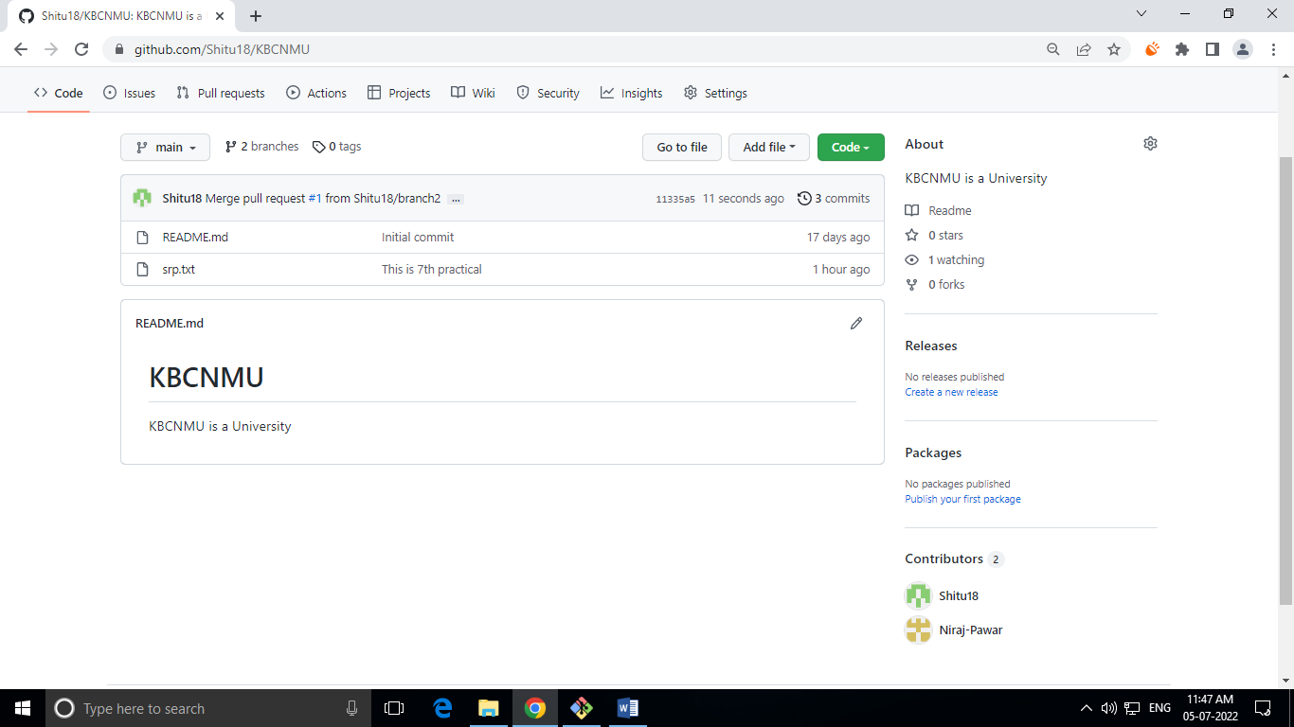

Roll No:-45
Name:-Jayant Sanjay Patil
Practoical No:-9
Practical Name:-Demonstrate the use of git diff command.

Nikhil@Dknik MINGW64 ~ (master)
$ git clone https://github.com/jayant1720/jayant1720.git
Cloning into 'jayant1720'...
remote: Enumerating objects: 6, done.
remote: Counting objects: 100% (6/6), done.
remote: Compressing objects: 100% (4/4), done.
remote: Total 6 (delta 0), reused 0 (delta 0), pack-reused 0
Receiving objects: 100% (6/6), done.

Nikhil@Dknik MINGW64 ~ (master)
$ cd jayant1720

Nikhil@Dknik MINGW64 ~/jayant1720 (main)
$ touch jayant.txt

Nikhil@Dknik MINGW64 ~/jayant1720 (main)
$ git add jayant.txt

Nikhil@Dknik MINGW64 ~/jayant1720(main)
$ git init
Reinitialized existing Git repository in C:/Users/Nikhil/jayant1720/jayant1720/.git/

Nikhil@Dknik MINGW64 ~/jayant1720(main)
$ touch jayant.txt

Nikhil@Dknik MINGW64 ~/jayant1720(main)
$ git add jayant.txt

Nikhil@Dknik MINGW64 ~/jayant1720 (main)
$ notepad jayant.txt

Nikhil@Dknik MINGW64 ~/jayant1720 (main)
$ git commit -m "MCA"
[main 078d7c0] MCA
1 file changed, 0 insertions(+), 0 deletions(-)
create mode 100644 rutikkharche.txt

Nikhil@Dknik MINGW64 ~/jayant1720 (main)
$ git diff
diff --git a/jayant.txt b/Jayant.txt
index e69de29..c6cff8b 100644
--- a/jayant.txt
+++ b/jayant.txt
@@ -0,0 +1,3 @@
+hello I am jayant
+I have completed asdm practical no 9
\ No newline at end of file

Output:-

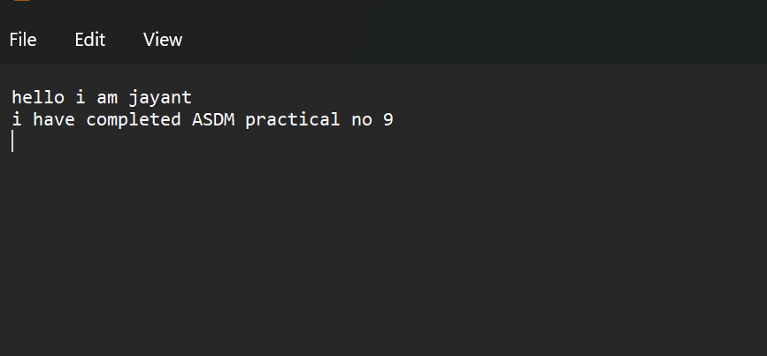

Practical No:-2
Name :- Jayant Sanjay Patil
Roll NO:- 45
Practical Name: clone the repository at
https://github.com/jayant1720/jayant1720.git

91788@Jayant MINGW64 ~
$ git version
git version 2.36.0.windows.1

91788@Jayant MINGW64 ~
$ git --help
usage: git [--version] [--help] [-C <path>] [-c <name>=<value>]
[--exec-path[=<path>]] [--html-path] [--man-path] [--info-path]
[-p | --paginate | -P | --no-pager] [--no-replace-objects] [--bare]
[--git-dir=<path>] [--work-tree=<path>] [--namespace=<name>]
[--super-prefix=<path>] [--config-env=<name>=<envvar>]
<command> [<args>]

These are common Git commands used in various situations:

start a working area (see also: git help tutorial)
clone Clone a repository into a new directory
init Create an empty Git repository or reinitialize an existing one

work on the current change (see also: git help everyday)
add Add file contents to the index
mv Move or rename a file, a directory, or a symlink
restore Restore working tree files
rm Remove files from the working tree and from the index

examine the history and state (see also: git help revisions)
bisect Use binary search to find the commit that introduced a bug
diff Show changes between commits, commit and working tree, etc
grep Print lines matching a pattern
log Show commit logs
show Show various types of objects
status Show the working tree status

grow, mark and tweak your common history
branch List, create, or delete branches
commit Record changes to the repository
merge Join two or more development histories together
rebase Reapply commits on top of another base tip
reset Reset current HEAD to the specified state
switch Switch branches
tag Create, list, delete or verify a tag object signed with GPG

collaborate (see also: git help workflows)
fetch Download objects and refs from another repository
pull Fetch from and integrate with another repository or a local branch
push Update remote refs along with associated objects

'git help -a' and 'git help -g' list available subcommands and some
concept guides. See 'git help <command>' or 'git help <concept>'
to read about a specific subcommand or concept.
See 'git help git' for an overview of the system.

91788@Jayant MINGW64 ~
$ git clone https://github.com/jayant1720/jayant1720.git
Cloning into 'jayant1720'...
remote: Enumerating objects: 6, done.
remote: Counting objects: 100% (6/6), done.
remote: Compressing objects: 100% (5/5), done.
remote: Total 6 (delta 0), reused 0 (delta 0), pack-reused 0
Receiving objects: 100% (6/6), 133.91 KiB | 144.00 KiB/s, done.
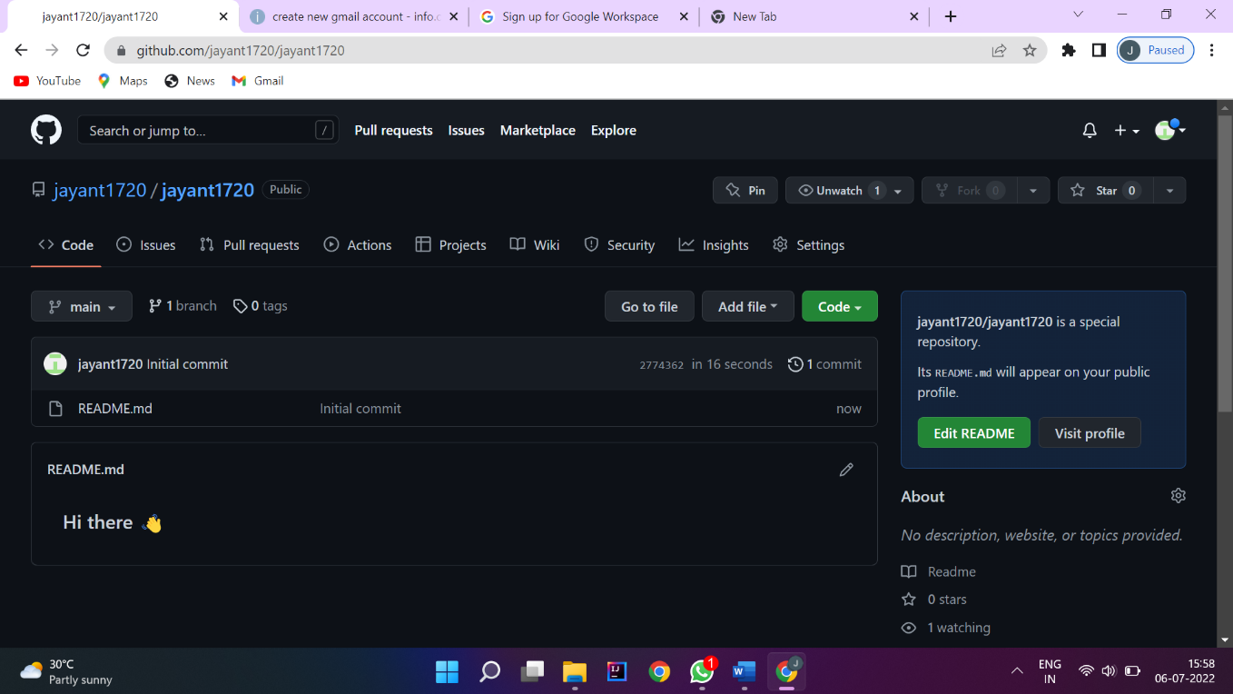

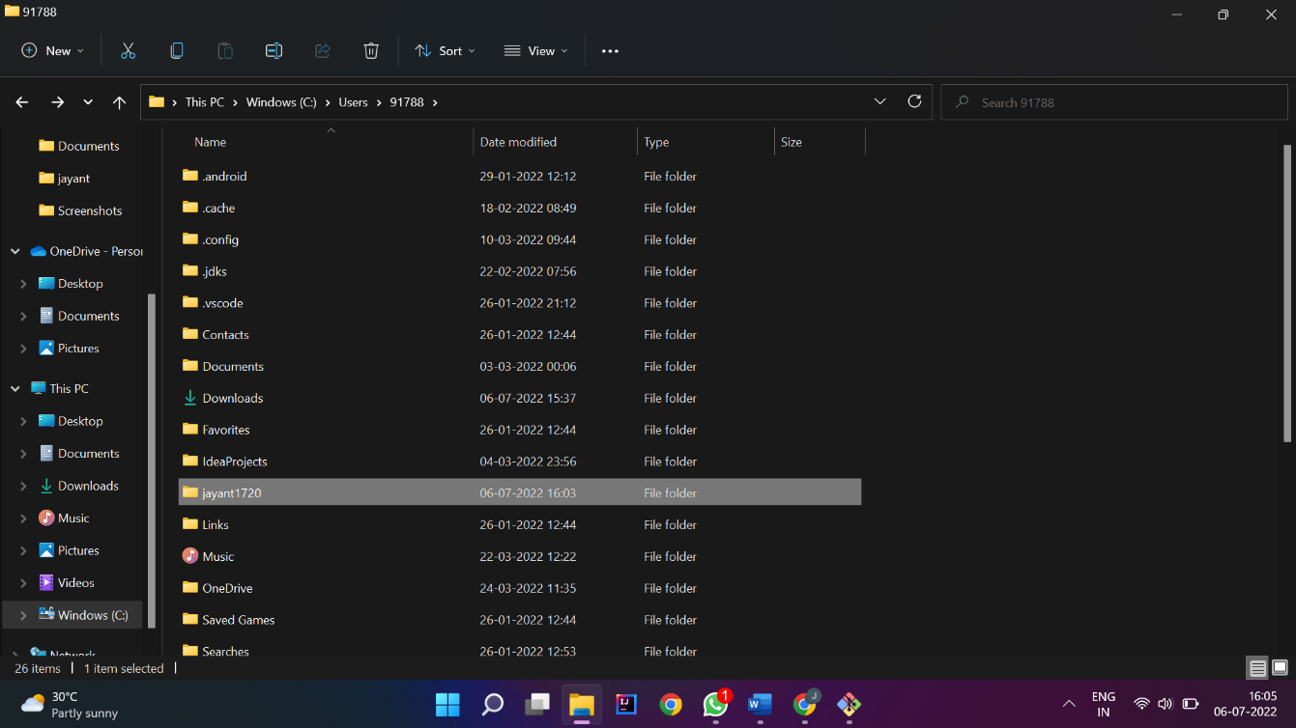

Practical No: 8
Name: Jayant Sanjay Patil
Roll NO:--45
Practical Name: Use git merge to merge you changes to the primary branch.

comp@com135 MINGW64 ~/KBCNMU (branch2)
$ git merge main branch2
Already up to date.

comp@com135 MINGW64 ~/KBCNMU (branch2)
$ git branch --list
* branch2
main

comp@com135 MINGW64 ~/KBCNMU (branch2)
$ git checkout main
Switched to branch 'main'
A rj.txt
Your branch is up to date with 'origin/main'.

comp@com135 MINGW64 ~/KBCNMU (main)
$ git pull https://github.com/Shitu18/KBCNMU.git
remote: Enumerating objects: 1, done.
remote: Counting objects: 100% (1/1), done.
remote: Total 1 (delta 0), reused 0 (delta 0), pack-reused 0
Unpacking objects: 100% (1/1), 631 bytes | 17.00 KiB/s, done.
From https://github.com/Shitu18/KBCNMU
* branch HEAD -> FETCH_HEAD
Updating 1597074..11335a5
Fast-forward
srp.txt | 0
1 file changed, 0 insertions(+), 0 deletions(-)
create mode 100644 srp.txt

Before Merge to local repository:
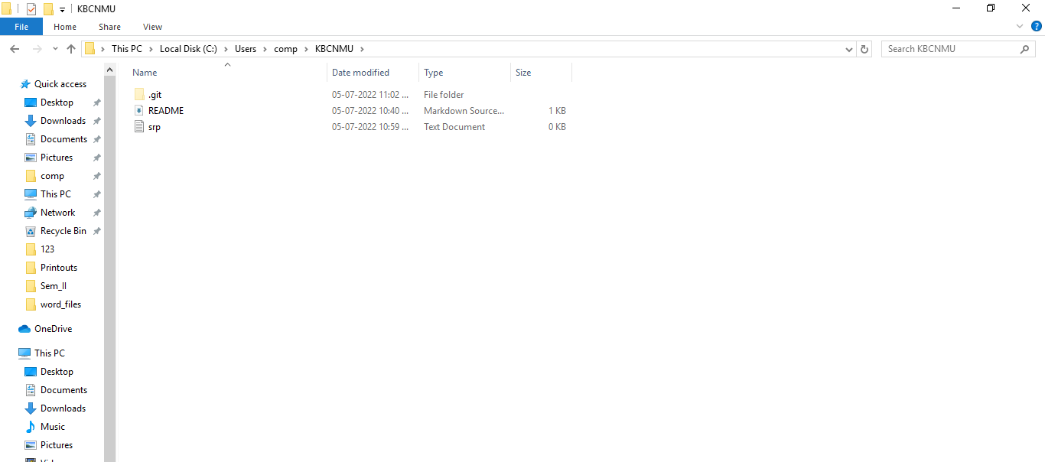

After Merge to local repository:
